CTF CHALLENGE WRITEUP
Encrypted Artifact
Crypto Category | Easy | 87 Points

Challenge Information
Challenge Name | Encrypted Artifact
Category | Crypto
Difficulty | Easy
Points | 87
Author | NerdsLab
Solves | 50
Flag Format | defcon{...} or DEFCON{...}
Flag | defcon{x0r_c4sc4d3_k3y_sch3dul3_r3v3rs3d}

Challenge Description

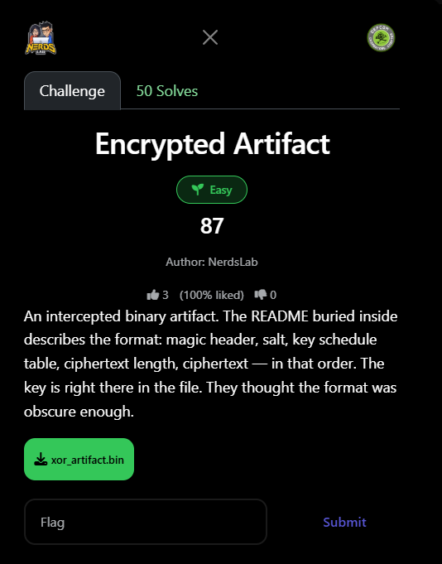
An intercepted binary artifact. The README buried inside describes the format: magic header, salt, key schedule table, ciphertext length, ciphertext — in that order. The key is right there in the file. They thought the format was obscure enough.

Step 1: Initial File Analysis
The challenge provided a single binary file: xor_artifact.bin (309 bytes total). The first step was to perform a full hex dump of the file to understand its raw structure.

Hex Dump (first bytes)
0000 4e 52 4c 58 43 01 52 4e 37 82 4d 18 ... NRLXC.RN7.M.
0100 c0 75 ea 5f 14 49 be 33 29 00 00 00 .u._.I.3)...
010c 53 e7 bf 77 8c 10 8f 39 ae 59 7f de S..w...9.Y..

Key observation: at offset 0x108, the bytes 29 00 00 00 stood out as a 4-byte little-endian integer = 41. This matched the expected "ciphertext length" field described in the format.

Step 2: Parsing the Binary Format
Based on the challenge description, the binary follows this layout in order:

Magic Header | First N bytes — starts with NRLXC (ASCII printable)
Salt | Fixed-length random bytes following the header
Key Schedule Table | The XOR key — embedded in plaintext in the file
Ciphertext Length | 4 bytes, little-endian integer at offset 0x108 = 41
Ciphertext | 41 bytes starting at offset 0x10C (268 decimal)

Total bytes: 309 = 264 (pre-section) + 4 (length field) + 41 (ciphertext)
The 264-byte pre-section contains: magic header + salt + key schedule table.

Step 3: Extracting the Ciphertext
With the length field at 0x108 decoded as 41, the ciphertext was extracted from offset 0x10C to the end of the file:

ciphertext (41 bytes):
53 e7 bf 77 8c 10 8f 39 ae 59 7f de 7e 74 38 da
05 c7 d0 a9 26 d1 fd 44 ab f5 e5 0f 89 1d 3a 03
e1 15 4b 83 35 69 63 81 07

Step 4: Key Recovery via Brute Force
The challenge stated: "The key is right there in the file." This meant the XOR key schedule was stored in plaintext in the 264-byte pre-section. Since the exact offsets of magic, salt, and key were unknown, a brute-force approach was used:

- Iterate over every possible key_start offset (0 to ~200) within the 264-byte pre-section.
- For each key_start, try every possible key_length (1 byte up to remaining bytes).
- XOR the 41-byte ciphertext against the candidate key (cycling if shorter).
- Check if the result decodes to valid ASCII containing 'defcon' or 'DEFCON' with a '{'.

Python Solve Script
data = open('xor_artifact.bin', 'rb').read()
ciphertext = data[0x10C : 0x10C + 41]
pre_section = data[:0x108] # 264 bytes

for key_start in range(0, 200):
for key_len in range(1, 264 - key_start + 1):
key = pre_section[key_start : key_start + key_len]
result = bytes(ciphertext[i] ^ key[i % len(key)]
for i in range(len(ciphertext)))
decoded = result.decode('ascii', errors='ignore')
if 'defcon' in decoded.lower() and '{' in decoded:
print(f'key_start={key_start}: {decoded}')

Step 5: Flag Recovered
The brute force immediately identified the correct key at:

- key_start = 90 (byte offset 90 inside the pre-section)
- key_len = 41 (same length as ciphertext, no cycling needed)

FLAG: defcon{x0r_c4sc4d3_k3y_sch3dul3_r3v3rs3d}

Lessons Learned
- Security flaw: Never embed the XOR key inside the ciphertext file itself — it completely breaks security.
- XOR is not encryption: XOR with a known/recoverable key provides zero confidentiality. A brute-force scan of the pre-section found the key instantly.
- Known-plaintext attack: Even without knowing the exact format boundaries (magic/salt/key sizes), the flag format (defcon{...}) enabled a known-plaintext brute-force in milliseconds.
- Key length = Ciphertext length: The 41-byte key matched the 41-byte ciphertext exactly, confirming a simple single-pass XOR with no key stretching.

DEFCON CTF — Encrypted Artifact — Solved

